The Other Side Part 1

Last year I did several newsletters using postcards as a theme. These pictures of our home town help to tell a story, however most serious collectors are just as interested in the reverse or back side of the card as well as the face. There are many things that one may find on the other side: a short message, which was the primary purpose of sending the card, a stamp, cancellations with dates, a publishers name, the name of the postcard company that printed the card, origin of country where the card was printed and many other interesting details. It was during the Golden Age of postcards (1900 to 1915) that we see postcards used as a primary means of communication much like the telephone and e-mail are used today. With this in mind I thought it might be interesting to flip them over and have a look at the other side in this story.
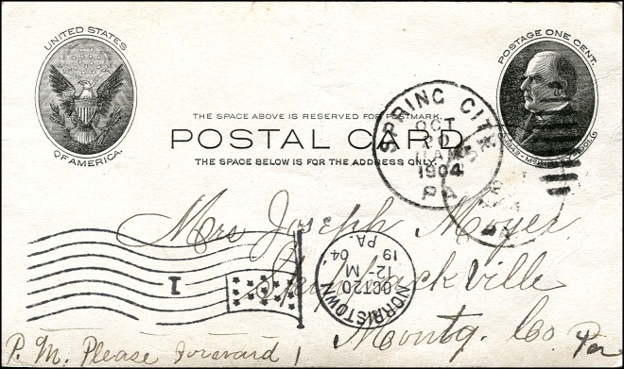
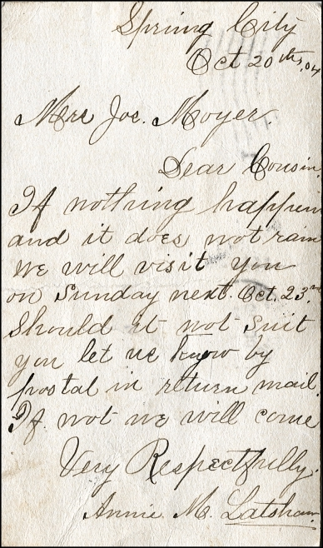
Mailed from Spring City in 1904 to Mrs. Joseph Moyer This early one-cent Postal Card was sold by the post office. The message:
“Dear Cousin, If nothing happens and it does not rain, we will visit you on Sunday next Oct. 23rd. Should it not suit you, let me know by postal in return mail. If not we will come. Very Respectfully, Annie M. Latshaw”

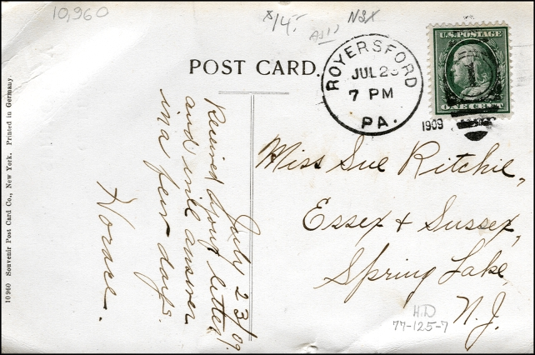
Mailed to Miss Sue Ritchie of Spring Lake New Jersey on October 23rd 1909, this card carries a Royersford hand stamp cancellation. The card was printed in Germany and numbered 10960. It was published by the Souvenir Postcard Company of New York. In pencil at the bottom are the initials H.D. indicating the card came out of the Hy Doty collection of Chester County postcards. (At the time of his death back in the eighties Hy Doty had one of the largest collections of Chester County Postcards ever assembled.) At the top is $14, the asking price for this card at the time of purchase twelve years ago. The message was as follows: July 23/09 - Received your letter and will answer in a few days. Horace.

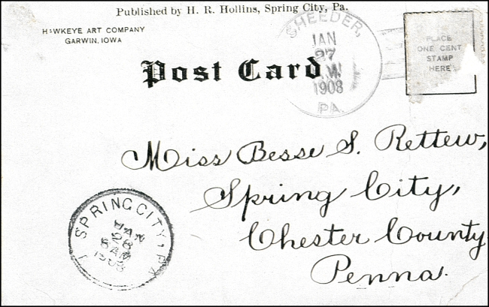
Mailed from Sheeder to Sp ring City on January 27th, 1908 this card was canceled in Spring City on the 28th and delivered to Miss Besse S. Rettew. The stamp was removed at one time, probably by a misguided stamp collector. The message on this undivided back card was on the front and said: Did you ever see this place? F. M. D. The card was published by H. R. Hollins of Spring City, a publisher that I first heard of in 2003 when this card surfaced. The photo on the card was of the Birchrunville Store.

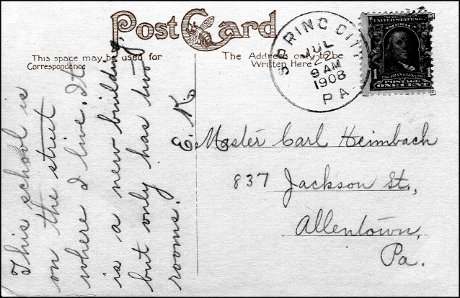
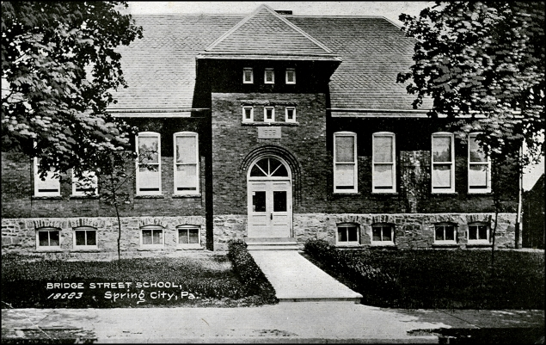
The front of this card shows a photo view of the new school on Bridge Street in Spring City. The message is informative: This school is on the street where I live. It is a new building (1908) but only has two rooms. E. K.

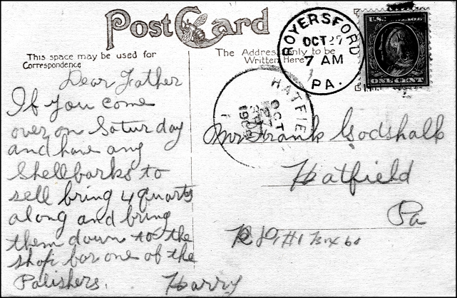
The message on this 1909 card reads: Dear Father If you come over on Saturday and have any Shellbarks to sell bring 4 quarts along and bring them down to the shop for one of the Polishers. Harry

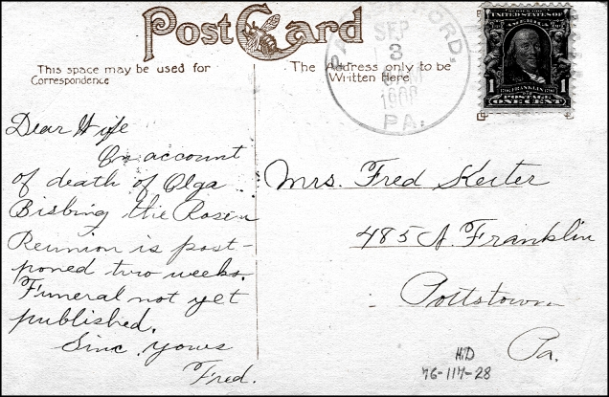

This 1908 card was mailed from Parkerford to Pottstown. It was sent by Fred Kecter to his wife and says: Dear Wife, On account of death of Olga Bisbing the Rosen Reunion is postponed two weeks. Funeral not yet published. Sinc. Yours Fred

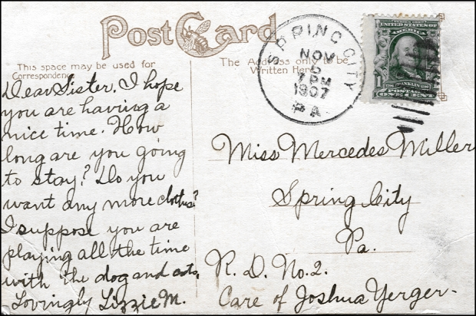
This card was mailed to Miss Mercedes Miller in care of Joshua Yerger RD #2 Spring City Pa in 1907. It says: Dear Sister, I hope you are having a nice time. How long are you going to stay? Do you want any more clothes? I suppose you are playing all the time with the dog and cats. Lovingly Lizzy M.

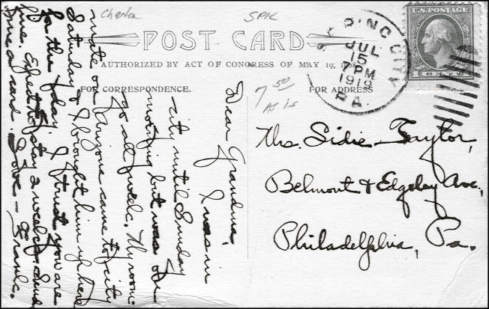
Dear Grandma, I was in the city until Sunday morning but was on the go all week. My room-mate on Arizona came to city on Saturday & I bought him up here (Spring City) for the day. I trust you are fine. Expect to stay 2 weeks. Send me a card. Love Frank is the message on this 1919 postcard mailed to Grandma Taylor in Philadelphia.

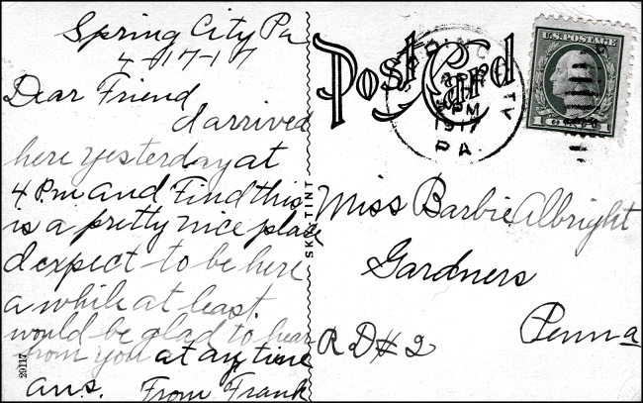
Spring City Pa 4-17-17 Dear Friend, I arrived here yesterday at 4 P.M. and Find this is a pretty nice place. I expect to be here awhile at least would be glad to hear from you at any time. ans. From Frank is the message on this 1917 postcard that was sent to a Miss Barbie Albright of Gardners. One week later he has found a job and you can see the follow up card sent to Barbie.
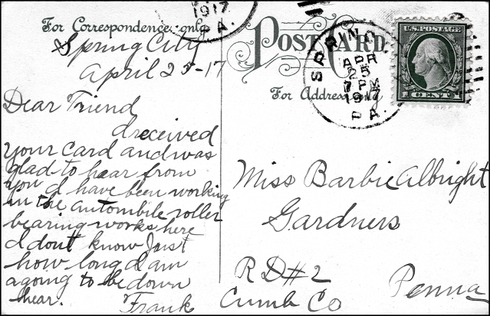

Spring City Pa 4-25-17
Dear Friend, I received your card and was glad to hear from you. I have been working in the automobile roller bearing works. I don’t know Just how long I am going to be down here. Frank

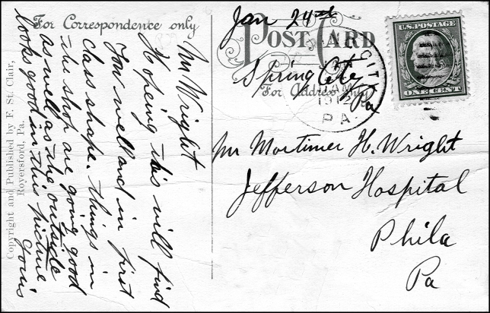
Mortimer H. Wright was in the Jefferson Hospital when this postcard of the shafting works was sent to him in 1912. The message reads: Mr. Wright, Hoping this will find you well and in first class shape. Things in the shop are going good as well as the outside looks in this picture. Yours

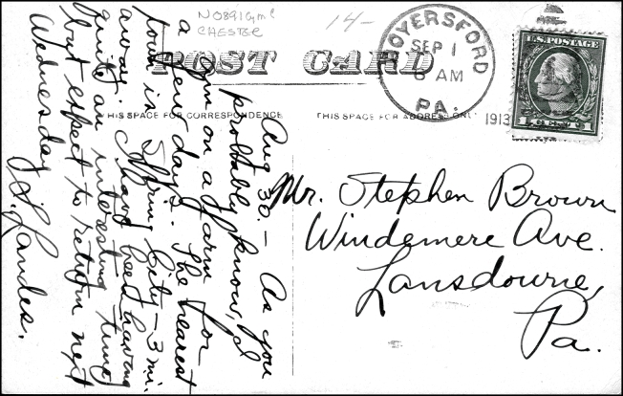
Steven Brown received this message in 1913 from S. Landes: Aug 30. - As you probably know, I am on a farm for a few days. The nearest town is Spring City – 3 miles away. I have been having quite an interesting time but expect to return next Wednesday. S. Landes

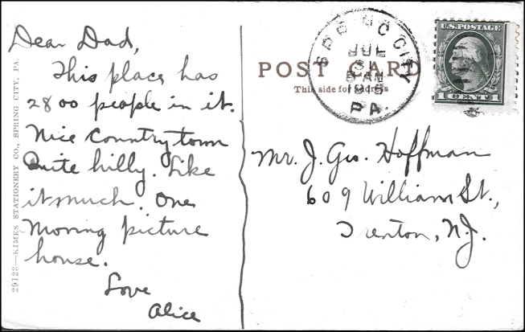
In a card dated from 1915 we see a short description of the town of Spring City: Dear Dad, This place has 2800 people in it. Nice country town - Quite hilly. Like it much. One moving picture house. Love Alice

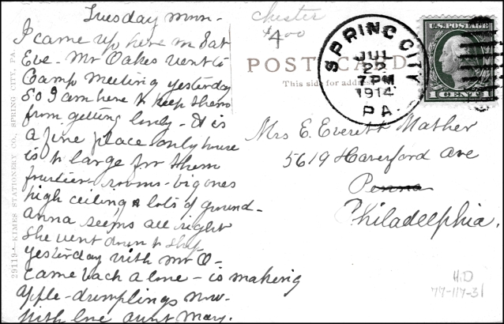
In a card dated from 1914 Aunt Mary writes to her niece in Philadelphia: Tuesday morn, I came up here on Sat. Eve- Mr. Oakes went to Camp Meeting yesterday So I am here I keep them from getting lonely. It is a fine place only house is too large for them. Fourteen rooms – big ones, high ceilings and lots of ground. Anna seems alright. She went down to shop yesterday with Mr. O. came back alone. Is making apple dumplings now. With Love Aunt Mary

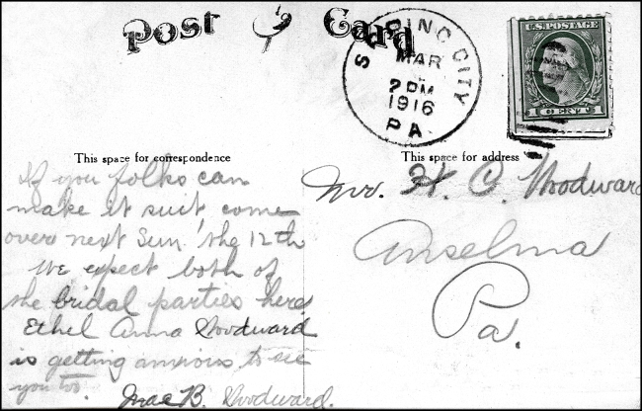
Mae B. Woodward in March of 1916, writing to Mr. H. C. Woodward of Anselma writes: If you folks can make it suit come over next Sun. the 12th. We expect both of the bridal parties here. Ethel Anna Woodward is getting anxious to see you too. Mae B. Woodward.

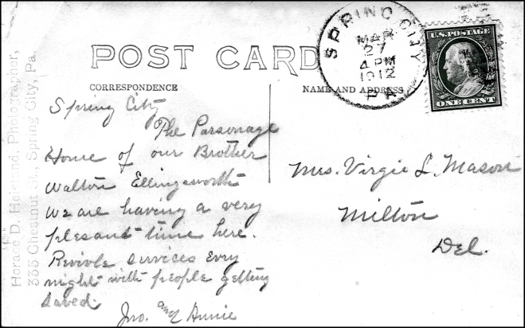
In a 1912 card mailed to Mrs. Virgil L. Mason of Delaware the message reads: Spring City, The Parsonage House of our brother Walton Ellingsworth. We are having a very pleasant time here. Revival services every night with people getting saved. JWO and Annie. The parsonage was the Methodist building on Broad Street at the top of the hill.
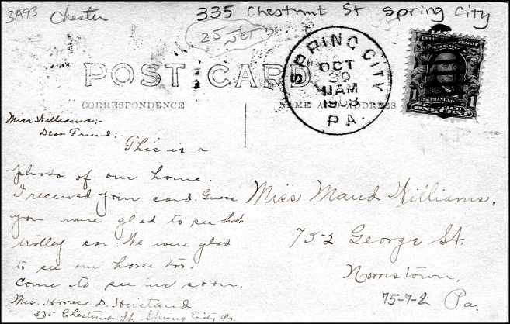
Miss Williams, Dear Friend, This is a photo of our home. I received your card. Guess you were glad to see that trolley car. We were glad to see our horse too. Come to see us soon. Mrs. Horace D. Hiestand, 335 Chestnut Street, Spring City, Pa. This is the message from Horace Hiestand’s wife sent to her friend Maude Williams of Norristown in 1908. The photo of there house was one of many photo-postcards that her husband Horace had published.
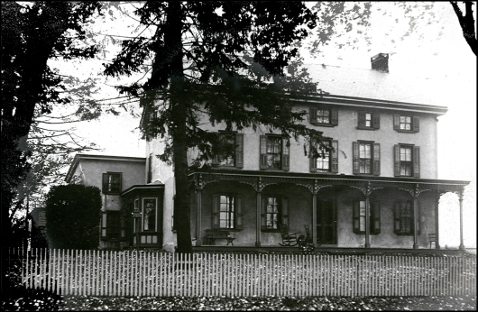
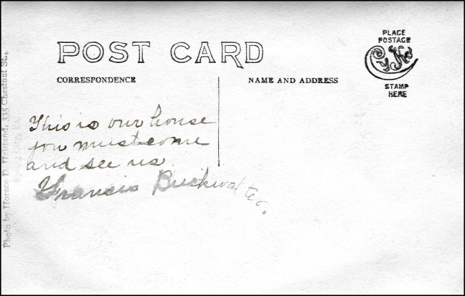

This is our house you must come and see me, Francis Buckwalter

is the short message on the back of this photo postcard.

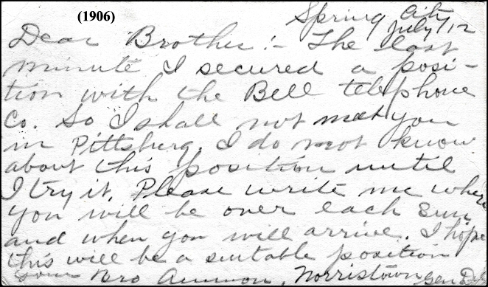
Spring City, July 12^{th,} 1906. Dear Brother, The last minute I secured a position with the Bell Telephone Co. So I shall not meet you in Pittsburg. I do not know about this position until I try it. Please write me where you will be over each Sun. and when you will arrive. I hope this will be a suitable position. Your Bro Arron, Norristown Gen Del
By William C. Brunner

